**Generating Word Cloud in Python**

Word Cloud is a data visualization technique used for representing text data in which the size of each word indicates its frequency or importance. Significant textual data points can be highlighted using a word cloud. Word clouds are widely used for analyzing data from social network websites.

For generating word cloud in Python, modules needed are – matplotlib, pandas and wordcloud. To install these packages, run the following commands :

pip install matplotlib

pip install pandas

pip install wordcloud

The dataset used for generating word cloud is collected from UCI Machine Learning Repository. It consists of YouTube comments on videos of popular artists.  
Dataset Link : <https://archive.ics.uci.edu/ml/machine-learning-databases/00380/>

Below is the implementation :

*filter_none*

*brightness_4*

|  |
| --- |
| # Python program to generate WordCloud    # importing all necessery modules  from wordcloud import WordCloud, STOPWORDS  import matplotlib.pyplot as plt  import pandas as pd    # Reads 'Youtube04-Eminem.csv' file  df = pd.read_csv(r"Youtube04-Eminem.csv", encoding ="latin-1")    comment_words = ' '  stopwords = set(STOPWORDS)    # iterate through the csv file  for val in df.CONTENT:        # typecaste each val to string      val = str(val)        # split the value      tokens = val.split()        # Converts each token into lowercase      for i in range(len(tokens)):          tokens[i] = tokens[i].lower()        for words in tokens:      comment_words = comment_words + words + ' '      wordcloud = WordCloud(width = 800, height = 800,                  background_color ='white',                  stopwords = stopwords,                  min_font_size = 10).generate(comment_words)    # plot the WordCloud image  plt.figure(figsize = (8, 8), facecolor = None)  plt.imshow(wordcloud)  plt.axis("off")  plt.tight_layout(pad = 0)    plt.show() |

**Output :**  
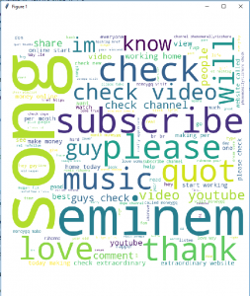  
The above word cloud has been generated using Youtube04-Eminem.csv file in the dataset. One interesting task might be generating word clouds using other csv files available in the dataset.

**Advantages of Word Clouds :**

1. Analyzing customer and employee feedback.
2. Identifying new SEO keywords to target.

**Drawbacks of Word Clouds :**

1. Word Clouds are not perfect for every situation.
2. Data should be optimized for context.

**Reference :** <https://en.wikipedia.org/wiki/Tag_cloud>